Literacy Assessment Portfolio
Grade 4 Student

Natasha Gibson
EDTE 500: Principles of Teaching and Learning
Ana Vieira
October 29, 2018

Table of Contents

Intermediate Student  (Grade 4) | Overview of the student | Use the reading interest survey and observations | 13
 | Data sources + Analysis | Predictions and Use of Text Features | 14
 |  | Literal Comprehension | 15
 |  | Main Idea and Supporting Details | 16
 |  | Making Connections | 17
 |  | Inferencing | 18
 |  | Quick Scale | 19
 |  | Overall Snapshot and Comments | 20
 | Learning/Teaching Plan | Strengths | 21
 |  | Needs | 21
 |  | Recommended next steps & instructional strategies | 21

Grade 4 Student “D” Overview
When I first arrived to work with this student, she was sitting with another girl and they had to separate; they were hesitant to split up but did eventually. I was assigned to be a reader/scribe for this student. I asked her if she would like to try reader the passages or if she would like me to; she wanted to read them. She started reading and really struggled with it. She was having a hard time getting through the first passage; her reading was very broken up. This tells me she could use help with her fluency. I helped her with tricky words but then took over reading the last 3 passages. This student said she enjoys reading for the most part. When asked if she was a good reader she replied with “Kind of, sometimes I have trouble reading.” This student said she reads both at home and at school but she reads more at school because there are more books there. When reading, she likes it when someone reads to her but she enjoys reading by herself more. I asked her what she does when she comes to a word she doesn’t know and replied with “I say I don’t know.” This tells me that she may not look up the word or ask for help. She told me that she does not have a favourite book which tells me that she has not connected really well with any books or that she did not want to tell me her favourite because she is shy. Finally, I asked her if she thinks reading is hard or easy, she told me it is both because she likes it but she struggles.

Predictions and Use of Text Features

I began by asking this student, “What do you think this passage is about?” She replied with “bugs and food.” This shows me that she is able to look at the front of the booklet and infer what the story might be about. However, she did not know why she inferred that, I explained what text features are without giving her an example and she still did not know. This tells me that she did not know weather the pictures helped her or weather the title helped her; she just knew it was about bugs and food. She was able to make a basic, obvious prediction about the text but was not able to identify any specific details.

Literal Comprehension

Using the pictures on the first page, the student was able to name all four bugs that the passage said are edible. This shows me that she is able to understand what the passage was telling her and where to look to find the answers. However, when she reached the next question, she looked on the pages a bit without really reading but she when she saw that the page said “4 cups” she said that as her answer without really knowing what she was reading. The answer was not 4 cups. This tells me that maybe she got tired of looking for an answer and gave the first one that she saw without really caring if it was right or wrong. It could also mean that she misread the passage and thought that the answer was 4 cups. This evidence shows me that the student is able to comprehend basic facts from the text but that she is not able to comprehend or identify key details of the passage.

Main Idea and Supporting Details
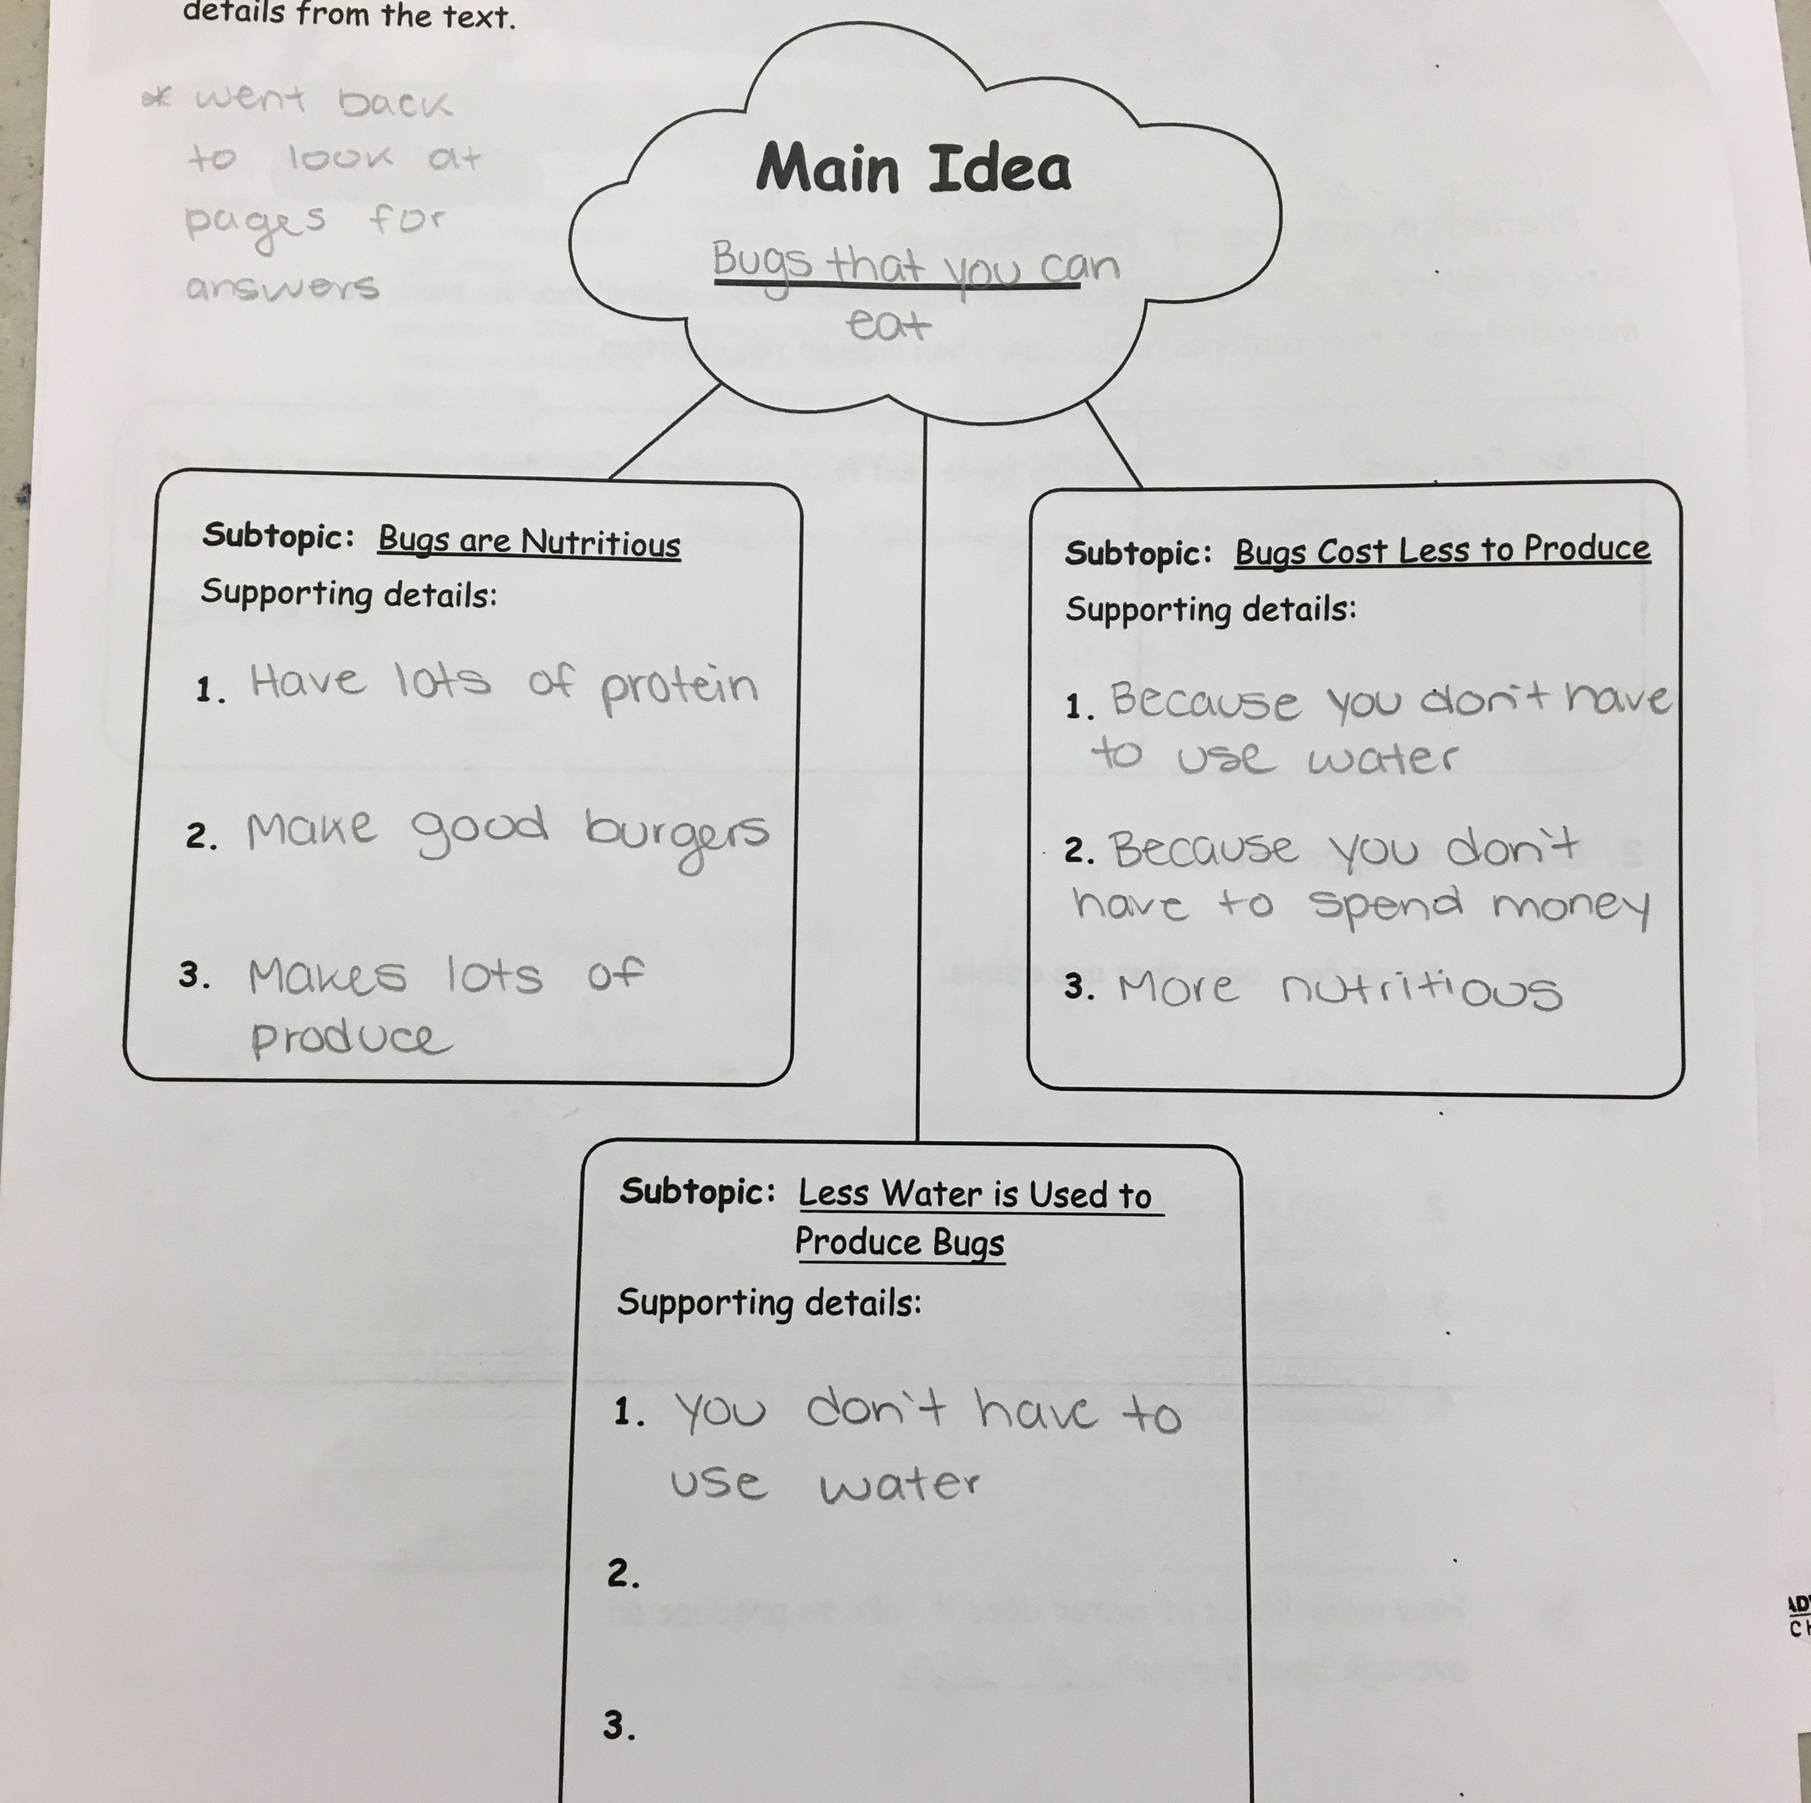
This student went back to read the passages when looking for the answers. She said the main idea was “bugs that you can eat.” This is a very general answer but a correct one; this shows me that she is able to understand the passage, at least on a surface level. I had to explain a few times what the subtopics were and helped her with where she might find answers. She was able to identify some supporting details for the subtopics but they were not always accurate or correct answers.
Making Connections
This student was able to connect a trip she took to the bug museum to the passages we just read about bugs and food. Her connection was good because she could see that both things were about bugs. Before she told me this connection, she told me a different one. She said that she used to eat bugs when she was little. This connection was way better because the passages were about eating bugs and how bugs can be used as food. She was too embarrassed about this and told me I was not allowed to write it on her assessment. This connection showed me that she is able to read a passage and connect it to something around her. In this case, she was able to make a ‘text to self’ connection. However, she was not able to provide a detailed explanation of how her connection compares to the passages. She said that her connection was different than the passage because they are bugs. I can infer that she meant that she is not a bug like the bugs in the story. This tells me that she is able to make somewhat meaningful connections to texts but she does not necessarily know why they are connected.

Inferencing

This student really struggled with inferencing. I had to repeat the question a few times and rephrase it before she felt confident enough to give me her answer. At first, she looked through the passage a bit and when she could not find the answer she looked frustrated. I told her that this is just what she thinks will happen based on what she has read but I think she still struggled with the abstract concept of inferencing. This student’s answer was not really related to the passage in any way. This tells me that she is not yet able to comprehend the passage at a deep level. She knew that her answer had to have something to do with food and what will happen when you eat but she did not relate it to what happened in the story.

Quick Scale
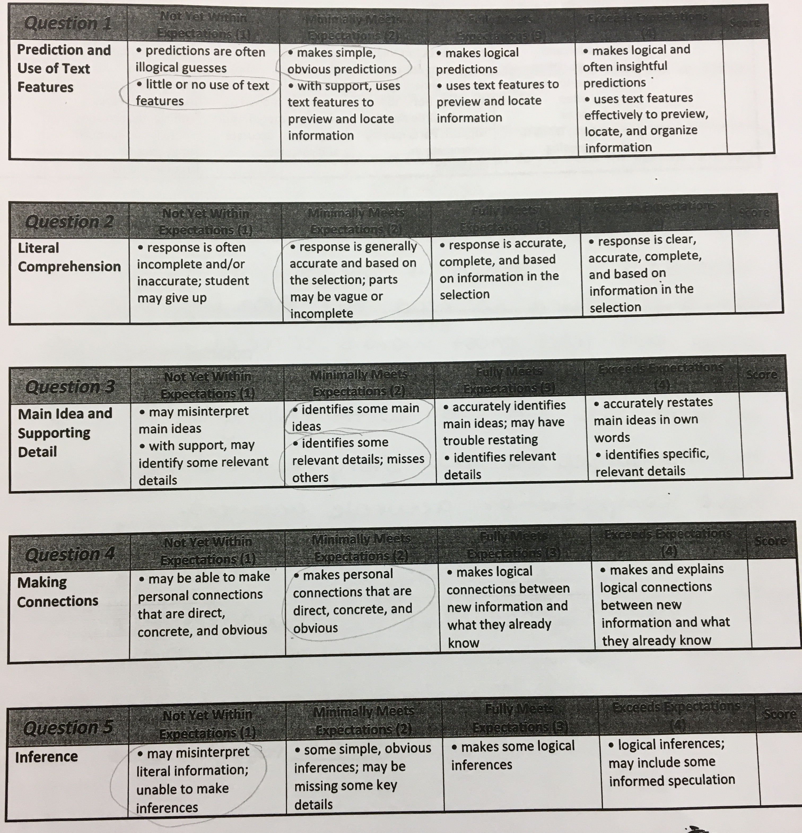
This student was generally in the Minimally Meets Expectations column and sometimes in the Not Yet Within Expectations column. This student struggled with her prediction and use of text features; she gave a basic prediction and was not able to use the text features to help her. She was able to identify some main ideas but struggles to identify key details to support them. She was able to connect to the story but unable to make inferences about the story.

Overall Snapshot and Comments
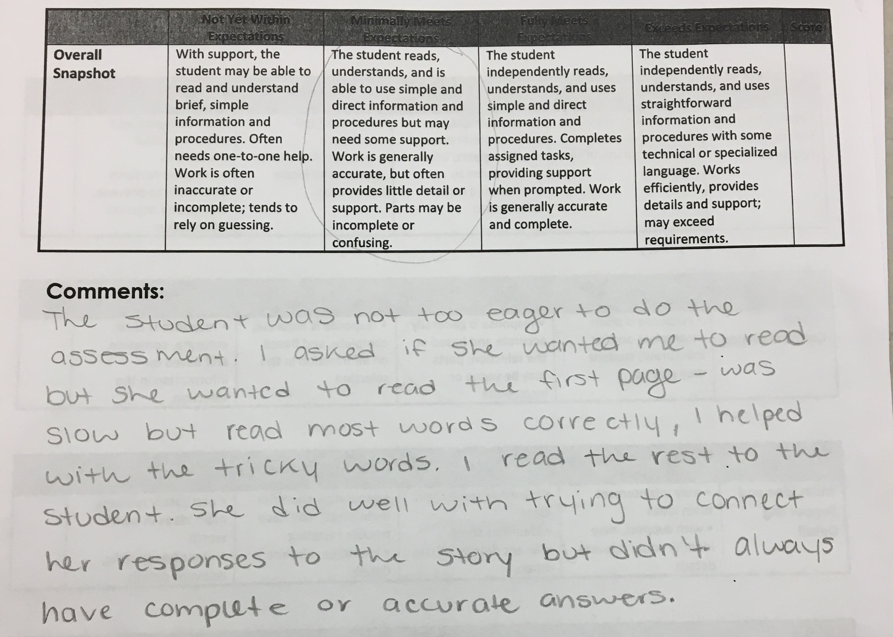
Overall, I put this student in the Minimally Meets Expectations column because she was able to read a bit of the story and she could understand the basic of what she read but she did not pick up on a lot of the key details. Most of her answers were simple and only partially correct but she was able to use the information she gathered to formulate a generally correct answer with some support. She often needed to reread the passage to find the answer to the questions. Some of her answers were confusing and not directly related the question.

STRENGTHS STRUGGLES STEPS
Reading assessment & School-Wide Write
Observations
Grade: 4
Strengths  - Even though I was there as a reader/scribe for her, she wanted to read the first page for me. This shows that she is motivated to be a better reader.  - She was able to comprehend the story quite well – she knew what was happening.  - She was able to make obvious predictions about the story, make basic connections to the story and identify some main ideas. | Struggles  - She did not want to do the assessment with me at the beginning – she did not want to move away from her friend.  - She gave very basic answers to the questions – I think she struggled to identify the details of the story.  - She struggled to make inferences about the text – I think she did not really understand what that means  - She struggled with fluency when reading to me at the beginning.
Next Steps / Strategies

- This student could use some work in Goal 4 of The Reading Strategies Book by Jennifer Serravello. Goal 4 is “Strategies for Reading Fluency.” She could use lesson ‘4.4 Make the Bumpy Smooth’ to help her reading smoothly or lesson ‘4.6 Punctuation at the End of a Sentence’ to help her know when to pause.

- This student could also use work in Goal 9 “Strategies for Determining Key Details.” She could use lesson ‘9.5 Gather Up Facts’ to help her find the details in the story or lesson ‘9.6 Consistently Ask, ”How Do I Know?”’ to help her connect the details of the story to the main ideas.

- This student could also use work in Goal 10 “Strategies for Understanding Text Features.” This student could use lesson ’10.2 Cover Up Then Zoom in’ to help her understand what the pictures/text feature are telling her about the story.

